

**Name:** Tayyab Zain

**Reg No:** 4293-FBAS/BSCS4/F20

**Subject:** Introduction to Data Base

**Submitted To:** Professor Imran Saeed

**Topic**

“**Super Store Data Base”**



**Preface**

1.0 Introduction

2.0 Existing System (No system or Manual System)

2.1 Issues/Drawbacks in Existing system

3.0 Proposed System

3.1 Advantages in Proposed System

4.0 Data Requirement

4.1 Entity Classes

4.2 Attributes of each Entity Class

4.3 Tables

4.4 Bubble Chart

4.5 Data Structure Diagram (DSD)

4.6 Entity Relationship Diagram (ERD)

5.0 Logical Data Model

5.1 Representation of Entity Classes

5.2 Represent Relationship

**Appendix-A**

6.0 Forms

7.0 Reports

**1.0 Introduction**

We are living in the age of information and information require data. But strong and sorting that data can be tricky and is a primary cause of concern for the major companies. If the data is not stored properly that loss of it can cause an entire company to sink, so we have to find a way to store the data somewhere reliable and efficient.

My Data Base is about “Super Store Organization”. These companies are so big and have so many products and services along with so many employees that it is impossible for them to exist without a system like this one. Through this system entire Organization and its data management and storage can be automated and can be accessed by the concerned authority at any time.

**2.0 Existing System (No system or Manual System)**

In existing system you have to keep the record of the organization’s employees, stores and products along with the growth report manually. Data can be easily lost because of this and is very hard to navigate through it to find what you are looking for. Moreover, the organization owner and its employees will face a lot of difficulty just trying to find and update a single record and the chances of human error are extremely high.

**2.1 Issues/Drawbacks in Existing system**

For a big organization which has its operation in multiple cities keeping data manually is a recipe for disaster.

* Lack of reliability
* Lack of efficiency
* Chances of increased human error

**3.0 Proposed System**

In proposed System, data is in data base and not manually. Employees info along with the info of the entire organization. We can also see the top stores in different cities bring in the most amount of sales and the top products of the company. Yearly report can also be used to keep track of the progress of the company.

For search a large organization explicit backup in mandatory and so we need to make sure we have one. In case of a loss of our primary data base we can use the explicit backup. If there is no such backup company is doomed to fail.

**3.1 Advantages in Proposed System**

Logically related data is stored in the proposed system and can now be accessed by multiple users at any time anywhere. This automated system will increase the reliability and efficiency. Calculation are done automatically and chances of human error has been removed. But the most important part is that now organization can see which products are most in demand and which stores are giving the highest returns allowing data analysists to analyze the data gathered in one place and direct the company in such a way that they can maximize their profit.

**4.0 Data Requirement**

Data requirements definition establishes the process used to identify, prioritize, precisely formulate, and validate the data needed to achieve business objectives.

In this project, I have stored the data in the form of tables, reports and form.

**4.1 Entity Classes**

I have included five entity classes named as follows:

* Organization (Information of different centers in different cities)
* Top Stores (Information about Top stores of the company)
* Top Product(Top products sold by the company)
* Employee (Information of Employees)
* Yearly Report (Yearly Report of the Organization)

**4.2 Attributes of each Entity Class**

* Organization (Company_Name, Center_Name, Center_ID, Ph_Number, Email)
* Top Stores (city, S_ID, Store Revenue, Email, Ph_Number)
* Top Products (P_Name, P_ID, No of sold products, Price, cost, Profit)
* Employee (E_Name, E_ID, Designation, Email, Phone Number)
* Yearly Report (Year, Revenue, Expenses, Profit, Tax)

**4.3 Tables**

**Table 1: Employee**

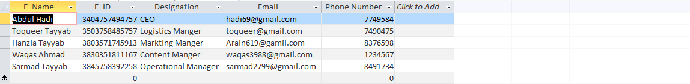

**Table 2: Organization**

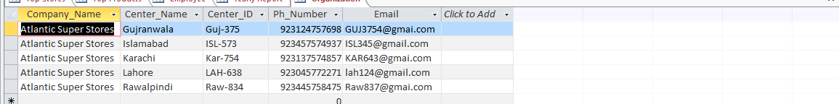

**Table 3: Top Products**

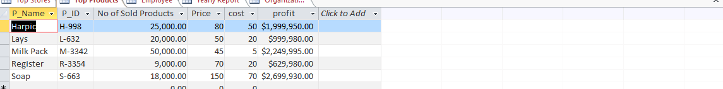

**Table 4: Top Stores**

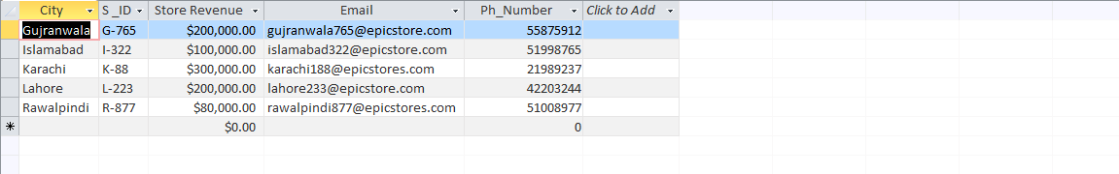

**Table 5: Yearly Report**

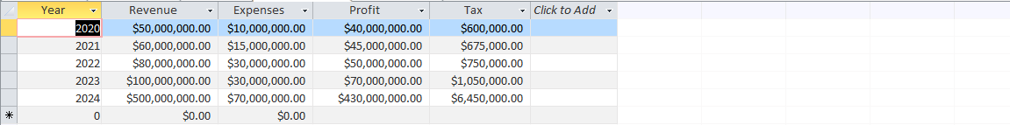

**4.4 Bubble Chart**

**Table 1: Employee**

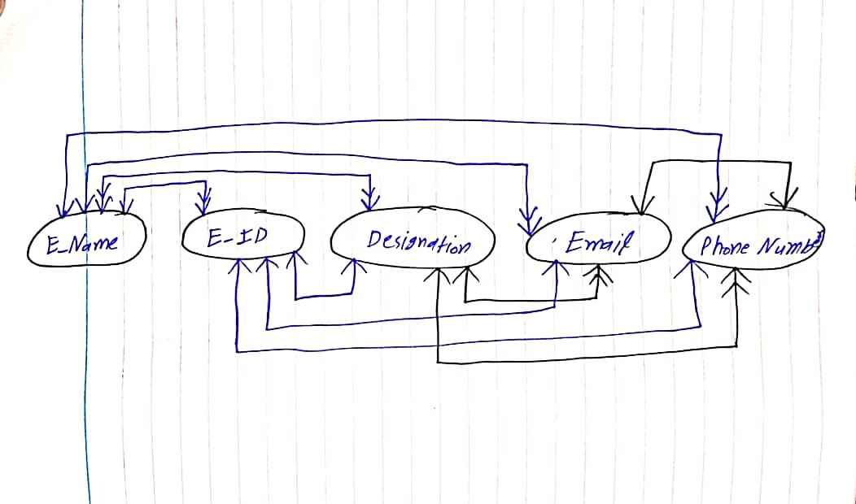

**Candidate Key Attribute:** E_ID, Phone Number, Email

**Primary Key Attribute:** E_ID

**Alternate Key Attribute:** Phone Number, Email

**Secondary Key Attribute:** NULL

**Non-Key Attribute:** E_Name, Designation

**Table 2: Organization**

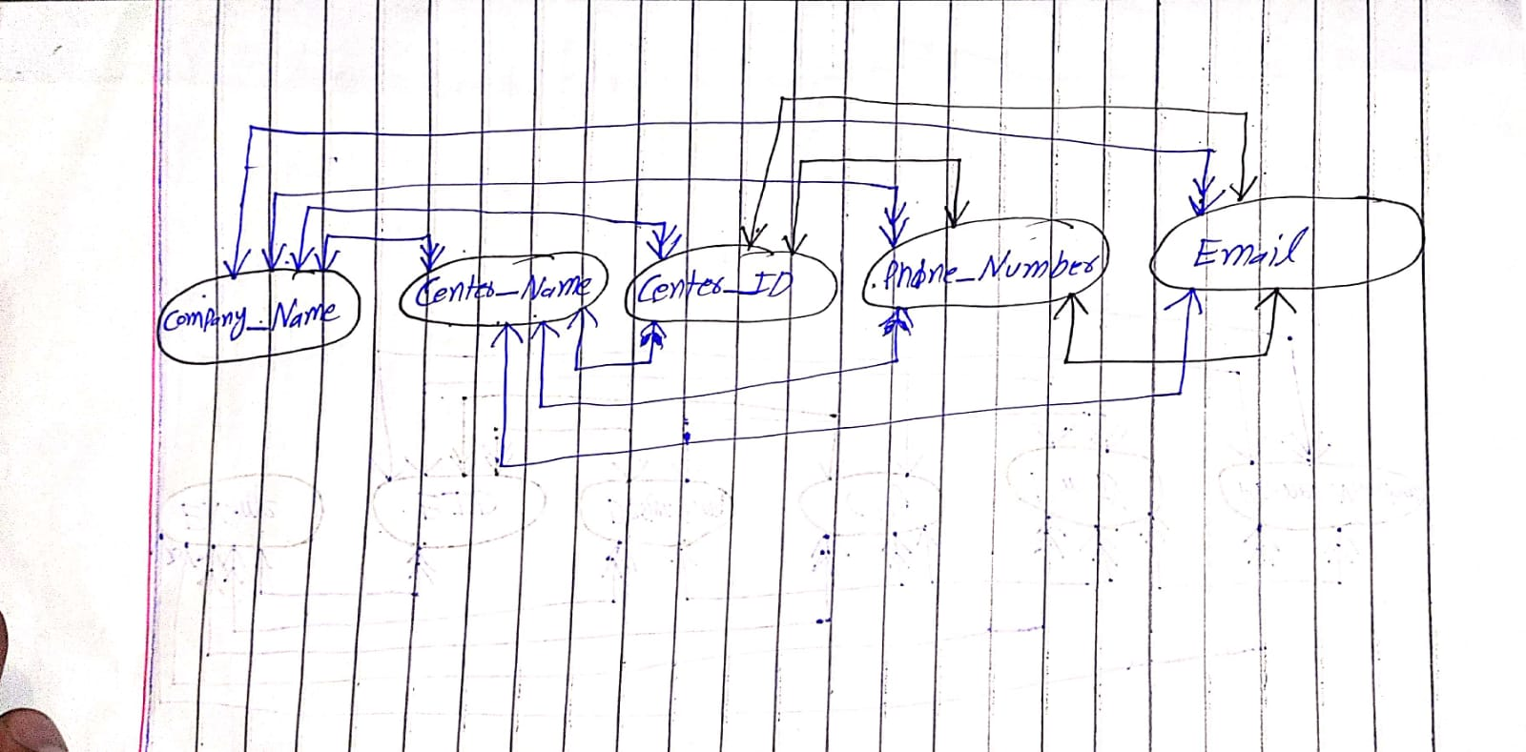

**Candidate Key Attribute:** Center_ID, Phone_Number, Email

**Primary Key Attribute:** Center_ID

**Alternate Key Attribute:** Phone_Number, Email

**Secondary Key Attribute:** NULL

**Non-Key Attribute:** Company_Name, Center_Name

**Table 3: Top Products**

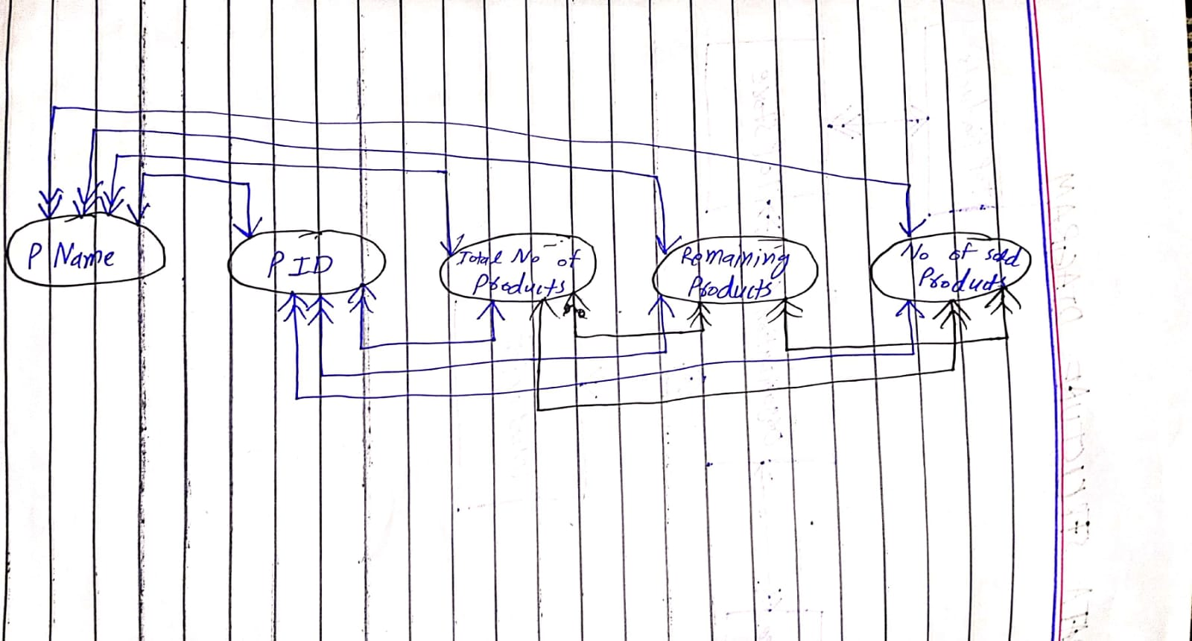

**Candidate Key Attribute:** P ID

**Primary Key Attribute:** P ID

**Alternate Key Attribute:** NULL

**Secondary Key Attribute:** P Name

**Non-Key Attribute:** Total Number of Products, Remaining Products, No of sold Products

**Table 4: Top Stores**

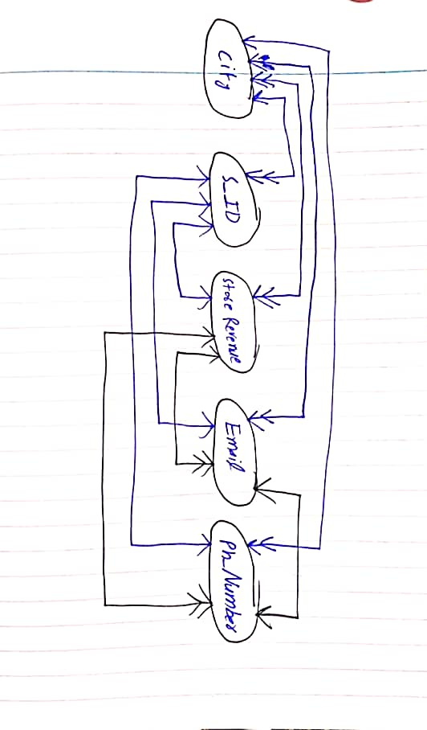

**Candidate Key Attribute:** S_ID , Email , Ph_Number

**Primary Key Attribute:** S_ID

**Alternate Key Attribute:** Store Email, Phone Number

**Secondary Key Attribute:** NiLL

**Non-Key Attribute:** city, Store Revenue

**Table 5: Yearly Report**

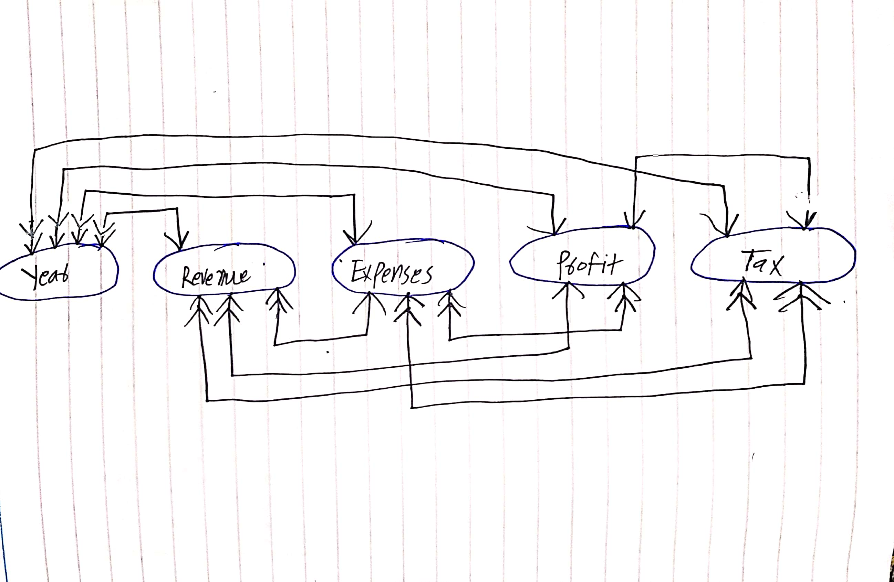

**Candidate Key Attribute:** Year

**Primary Key Attribute:** Year

**Alternate Key Attribute:** NULL

**Secondary Key Attribute:** NULL

**Non-Key Attribute:** Revenue, Expenses, Profit, Tax

**4.5 Data Structure Diagram (DSD):**

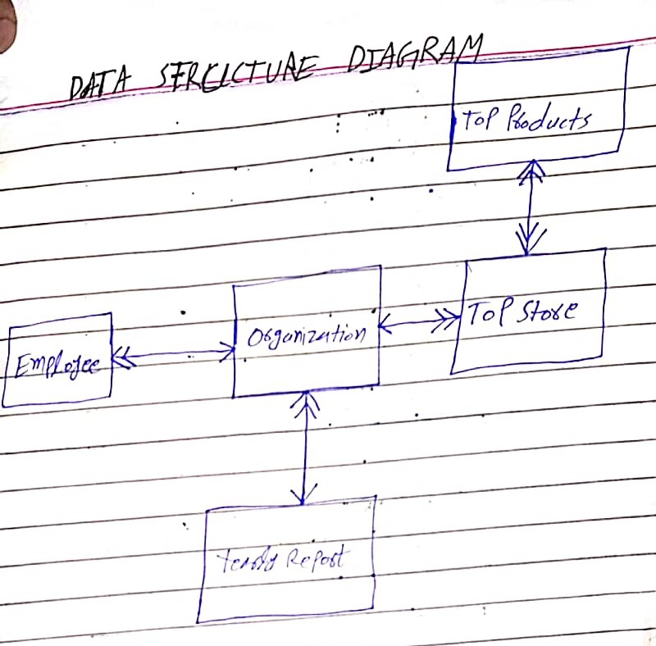

**4.6 Entity Relationship Diagram (ERD)**

**Entity Relationship Diagram (ERD) Old Convention:**

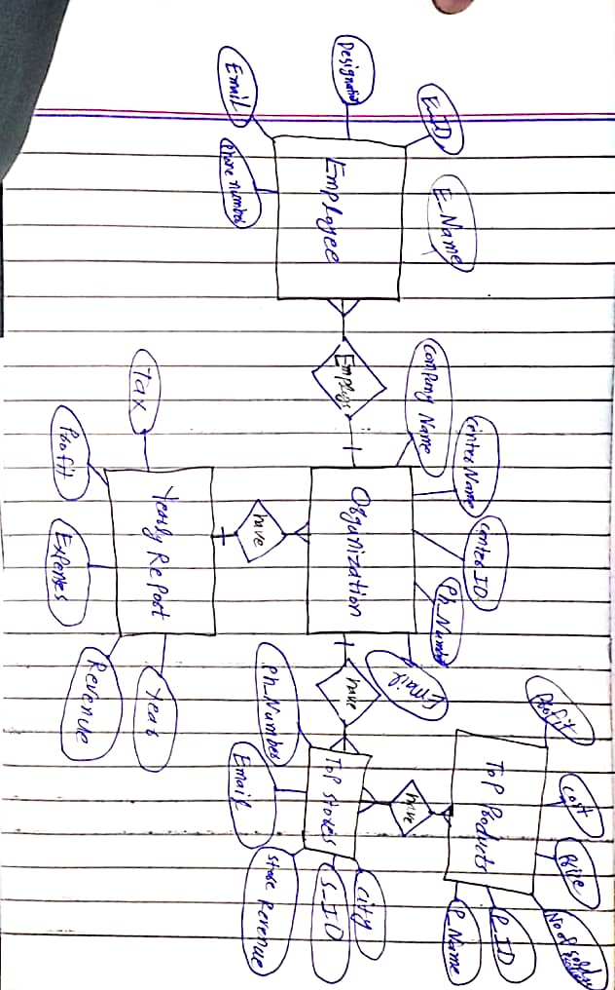

**Entity Relationship Diagram (ERD) new Convention:**

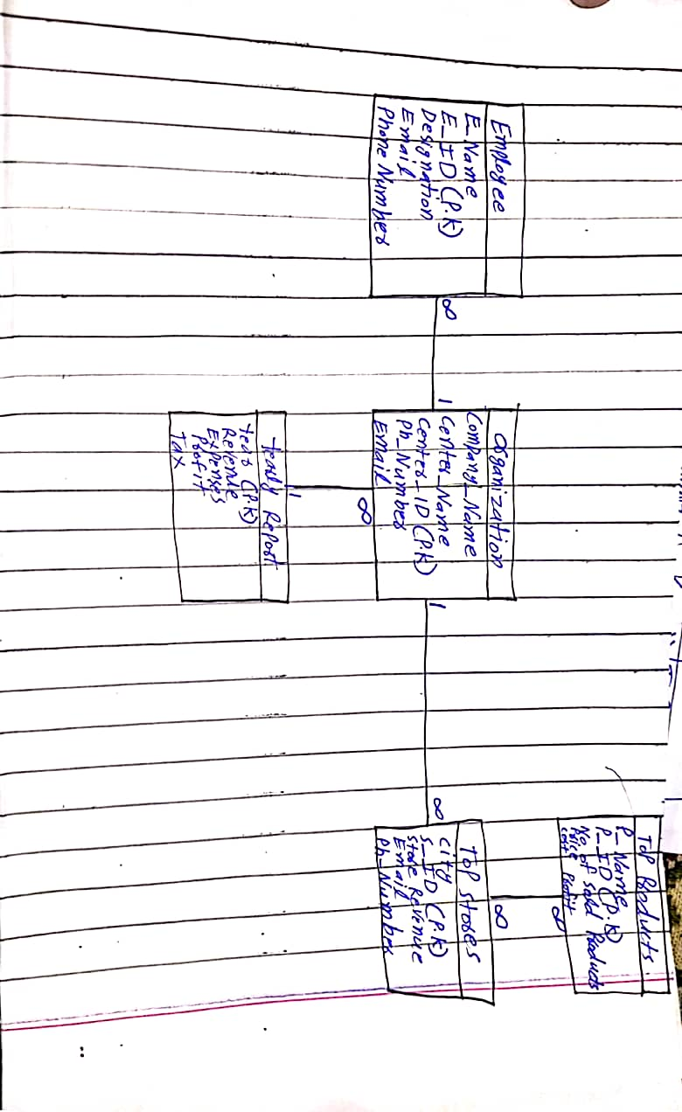

**5.0 Logical Data Model:**

* Organization (Company_Name, Center_Name, Center_ID, Ph_Number, Email)
* Top Stores (city, S_ID, Store Revenue, Email, Ph_Number)
* Top Products (P_Name, P_ID, No of sold products, Price, cost, Profit)
* Employee (E_Name, E_ID, Designation, Email, Phone Number)
* Yearly Report (Year, Revenue, Expenses, Profit, Tax)

**5.2 Representation of Relationship between Entity Classes**

Degree of a relationship and type of relationship is considered when representing relationship.

1. **Binary + 1: M (Organization-Employee)**

We have taken the primary key of one side relation (Organization) as a foreign key into the many side relation (Employee).Primary key of **"Center_ID”** has now become the foreign key in Employee entity class whose primary key is **“E_ID”.**

**2.** **Binary + 1: M (Organization-Top Stores)**

We have taken the primary key of one side relation (Organization) as a foreign key into the many side relation (Top Stores).Primary key of **“Center_ID”** has now become the foreign key in Employee entity class whose primary key is **“S_ID”.**

1. **Binary + M: M (Top Stores-Top Products)**

We take Primary key of Top Stores and Top Products both of which have Many to Many relationship with each other and have put them in a new table. So now the Primary key of Top Stores **“S_ID”** and Top Products **“P_ID”** both are foreign keys in a brand new table. Both primary keys in the new table acts as foreign keys and combine together to form a **Composite Primary** key related to both Top Stores and Top Products.

1. **Binary + 1: M (Organization-Yearly Report)**

We have taken Primary key of one side relation (Yearly Report) as a foreign key in many side relation (Organization). Primary key **“Year”** of Yearly Report now acts as the foreign key in Organization entity class.

**Appendix-A**

6.0 Forms

7.0 Reports

**6.0 Forms:**

**Form: Organization**

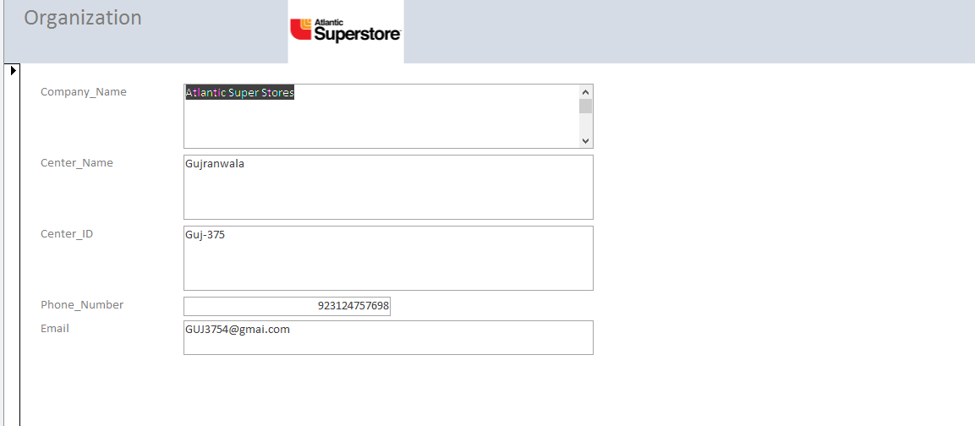

**Form: Employee**

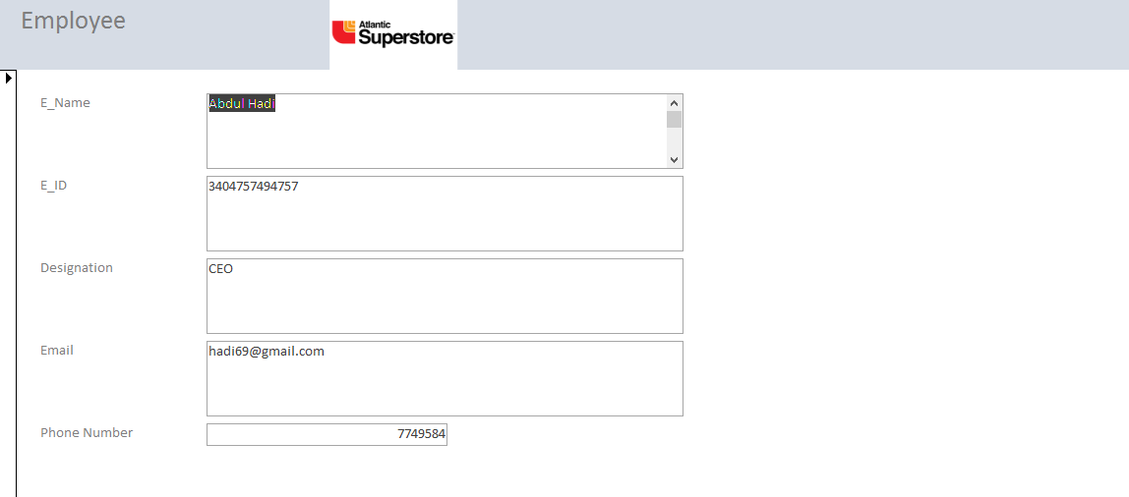

**Form: Top Products**

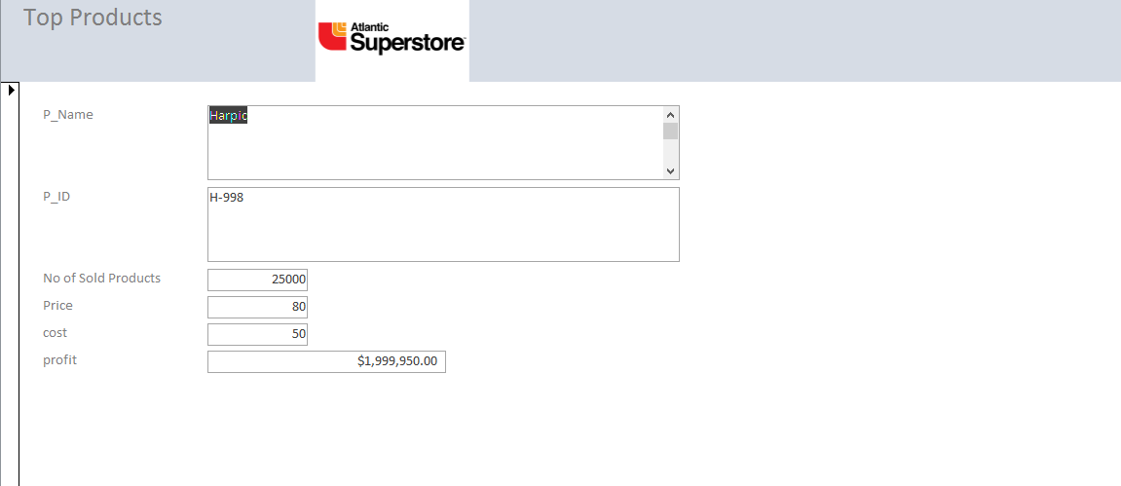

**Form: Top Stores**

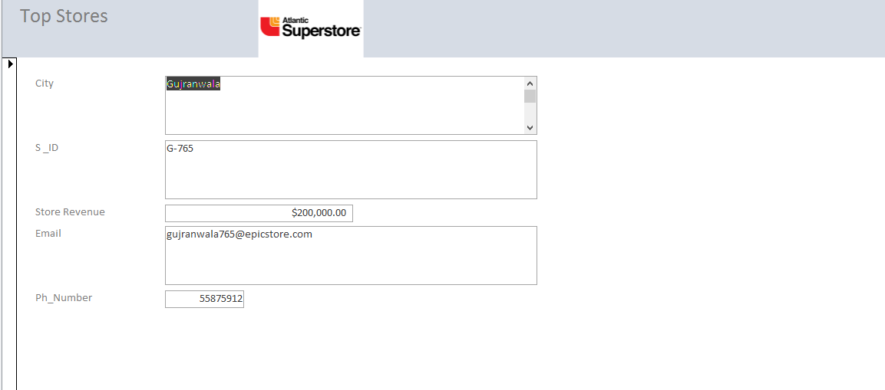

**Form: Yearly Report**

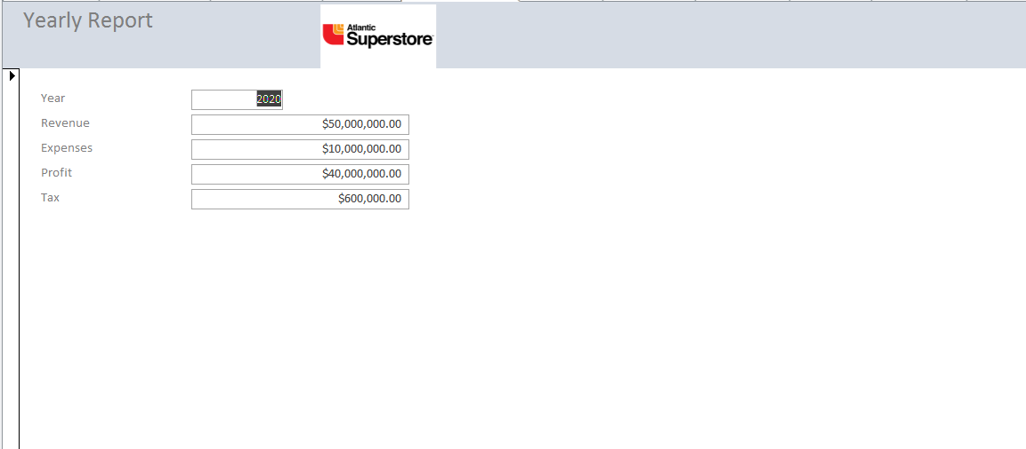

**7.0 Reports:**

**Report: Organization**

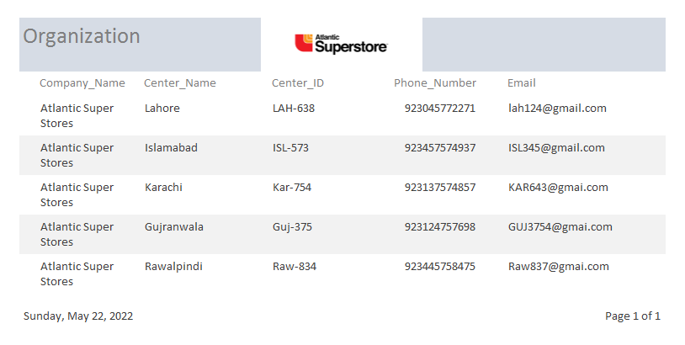

**Report: Top Stores**

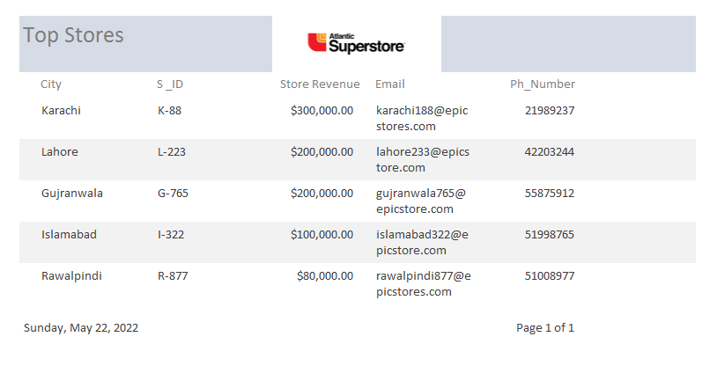

**Report: Top Products**

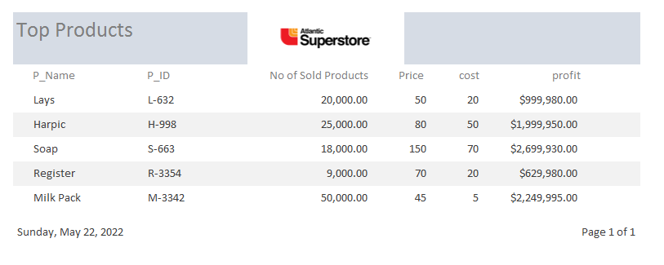

**Report: Employee**

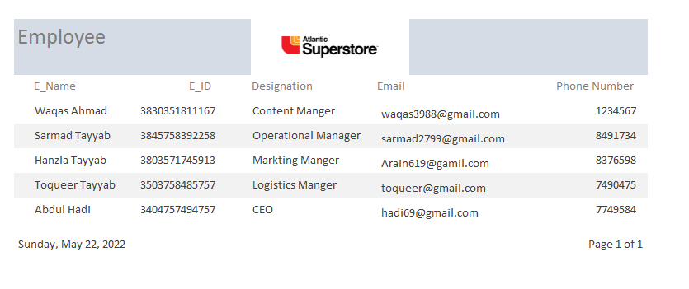

**Report: Yearly Report**

